|  |  |  |  |
| --- | --- | --- | --- |
| **OSEB EDUCATIONAL CONSULT-KAMPALA** | | | |
|  | | | |
| **TEACHERS’ HANDBOOK**    C:\Users\USER\Desktop\BOT 2024\Kids Playing with Lego.jpg  TERM 1 2024 | | | |
| **Name:** | | | |
|  | | | |
| **School:** | | | |
| STANDARD CURRICULUM | | | |
|  | **BABY CLASS LESSON NOTES TERM I 2024**  **Enjoy Our Quality Services** |  | **0775787978/0742845900** | |

**OSEB EDUCATIONAL SERVICES, KAMPALA**

**LESSON NOTES FOR BABY CLASS – ENGLISH TERM I - III**

**WEEK I: PERIOD I**

**CONTENT:**Sorting objects according to colours.

**Activities:**

* Sorting
* Reciting colours
* identifying colours

**Period 2:**

**Ryhme:**

**Period 3: Content:**

What is this……………..?

That is a …………………..

This is a …………………..



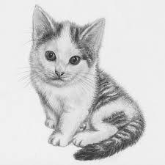



**Activities:**

* Matching
* Drawing
* Reading.

**Period 4 Content: Preposition**

On under

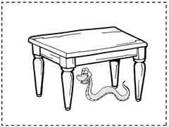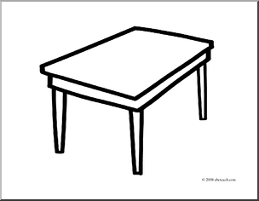

Activities

* Questioning and answering the given questions.
* Naming the materials used.

**Period 5: Content.**

a b c

a c

b a

c b

**Activities:**

* Reading
* Sorting
* Matching

**Matching and writing**

a c ______

b a a_____

c b _______

**Week 2: Period 1: Content: Identifying pictures and words.**

axe box

cat axe

box cat

**Read and write**

cat box axe apple

cat ___ ___ _______

**Activities:**

* reading
* spelling
* writing
* 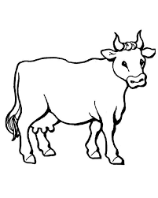matching

**Period 2: content: Riddle.**

I have two horns.

I have four legs.

I give you meat and milk

Who am I?

**Period 3: Content:** Colour identification. Green.

**Period 4: Content:** Actions:

driving, sweeping, crying.

Activities:

* Singing
* reciting colours and actions.
* acting accordingly.

**Period 5: content**: Reading and writing.

a b c

___ ___ ___

____ ___ ___

**Activities:**

* Reciting letters.
* Singing
* sorting
* reading
* writing

**Week 3: Period 1: content**: Identifying and recognizing pictures and words.

bed tie tie

mat bed ____

tie mat ____

Matching and drawing

**Period 2:**

sun axe ____

bag sun _____

axe bag _____

Activities:

* Reciting rhymes.
* Singing words
* Spelling words
* Drawing pictures.

**Period 3: Content:** Structural pattern

What is this…………..?

(Using the learnt objects)

Period 4: Colours.

Red colour.

What is the colour of your blood? …………

**Period 5: Content:**

letter interpretation.

c d

___ ____

____ ____

**Activities:**

* Reciting alphabet a – z
* singing a song
* tracing
* sorting out letters given
* writing the given letters.

**Week 4:**

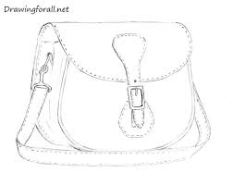**Period1: Content**:

sun

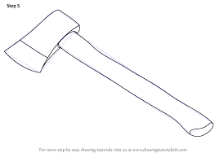axe

bag

Activities:

* Matching
* writing
* reading
* drawing

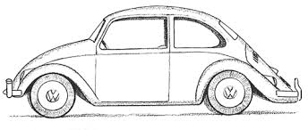**Period 2:**

tin __________

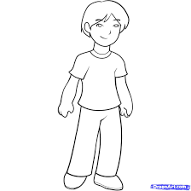boy ________

car boy

**Period 3:**

**Content: Preposition**

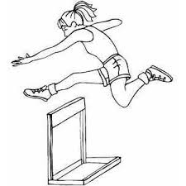 Where is the …………….?

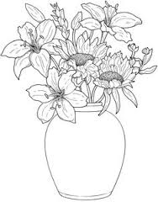

The flower is …………… the tin.

**Period 4: content:**

Colours: yellow, black.

Activities: Questions and answers.

What is the colour of ………………..?

* sun
* hair
* charcoal

**Period 5: Content:**

e f d e ___

e U e f f__

___ ___ f d ___

**Activities:**

* Reciting a - z
* sorting
* writing and matching

**Week 5**

**Period 1: Content: Identifying and recognizing the words**.

eye eye egg

cup box box

**Period 2:**

pot cat pot

tie tie tin

dog pig dog

Activities:

* Reciting the words.
* Reading words
* Spelling the words
* Ringing the same words.

**Period 3: Content:** Colour identification.

brown, pink

Activities:

* Sorting , reciting, telling the colour of the desk, soil, tongue.

**Period 4: Content**: Actions.

Looking at, running, skipping

**Activities**:

* Naming the actions.
* Acting upon the given actions.
* Accepting to take chances.

**Period5: Content:**

g h i

__ __ __

h g _____

i h h

g i ___

**Activities**:

* Reciting alphabet
* sorting the given letters.
* reading
* matching and writing the given letters.

**Week 6 Period 1: Content:**

box sun hoe cat egg ball

**Period 2:**

bag box



ball bed

 sun cat

**Ring the correct word.**

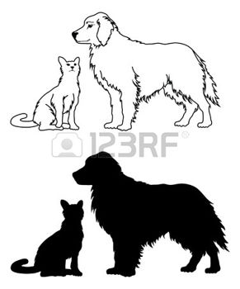

cat ball

* 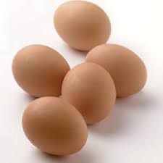

eggs boy

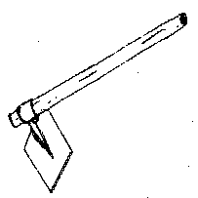

tie hoe

**Activities:**

* Spelling and reading the words.
* Identifying and recognizing the words and pictures.
* Ringing the correct words for the picture.

**Period 3: Content:** Colours.

green, grey.

Activities:

* Questioning and answering
* What is the colour of the ………..? leaf, grass, school sweater etc
* Sorting the given colours.
* Naming the colours.

**Period 4: Content: Preposition:**

near, behind.

**Period 5: Content:**

b m b c

q g s g

Ring the correct letter.

p a = C

t = ___

v >< = ___

**Activities**

* Reciting a - z
* sorting letters
* reading and ringing the correct letters.
* writing the letters correctly.

**Week 7: Period: 1 Content:**

tree, leg bus ear

Ringing the correct word.

moon mon

box bxo

**Period 2:** Filling in the missing letter.

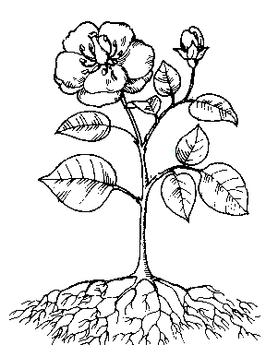

c _ t tr _ _

**Period 3:** Filling in the missing parts.

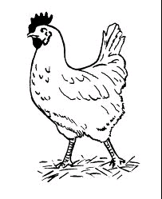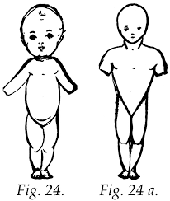  
**Period 4: Content: Riddle:**

I have two legs.

I give you chicken and eggs

What am I?

**Period 5: Content:**

**J k I m**

k m ____

j k k___

m j ____

**Write correctly.**

= j = k

k

j

**Activities:**

* Reciting letters a - z
* reading letters
* matching and writing
* sorting the given letters.

**Week 8; Period 1: Content**: Reading and spelling words.

rat hen hut

arm bed girl

Filling in the missing letters.

ar __ _xe b _ _ k

**Period 2: Content:**

egg ____ boy ______

box _____ tree _______

**Activities:**

* Reading and spelling words.
* Writing words
* Drawing pictures
* Filling in the missing letters.

**Period 3: Content**: Colours.

purple, orange.

**Period 4: Content: Actions:**

Standing, opening, pushing, climbing.

**Period 5: Content:** Ring the same letters.

**c k m**

e r r

c d o k n m

**Ring the letters.**



i x

o v

f j 7 m

**Activities**

* Sorting letters.
* Ring the same letters.
* Reciting letters a – z
* reading the letters a –z

**TERM III**

Lesson notes for English

Week I

Period 1

Content: Sorting objects according to colours.

**Period 2**

Rhyme of colours

Sun is yello.

Period 3-4

Three letter words

box, cat, tin, boy

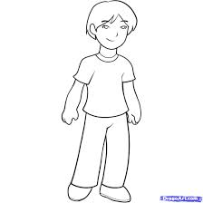Matching words to pictures

Tin

cat

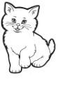boy

box

Period 5

Situational game

What is your name

My name is ………………

**Week 2.**

**Period 3**

**Content: Three letter words**

Sun

pot

eye

bag

**Period 2**

Activities

* Reciting
* Spelling
* drawing
* Matching
* Reading and writing

Period 2

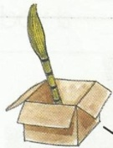Content: Preposition:

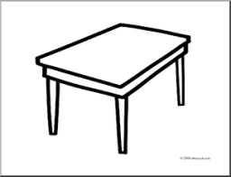Where is the ………………?

The ………is on the …………….

**Period 3**

Comparison of shapes and colours

.

 blue, red

Activities:

* Reading
* Acting accordingly
* Sorting

Period 4

Content: Letter names

a b c d

__ __ __ __

__ __ __ __

Activities

* Reading
* Sorting
* writing

Period 5

Content: Riddles

* I have two wings
* I fly in air
* What am I?

**Week 3**

Period I

Content: Vocabulary:

Bed eye tie ball

Match and draw

bed ball ________

eye bed

tie eye

ball tie

Activities:

* spelling
* reading
* matching
* drawing

**Period 2: Content**

Match and write

a d _d__

b c

c a

d b

**Activities**

* Reciting
* Reading
* Matching and writing

Period 3

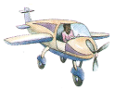Content: Preposition

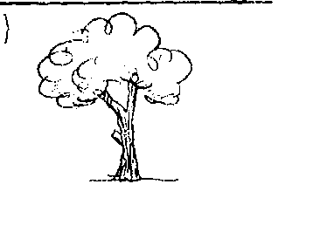

Period 4

Reciting a rhyme (butterfly x 2)

Period 5

* Having fun with language
* Saying tongue twister

**Week 4**

Period 1

**Letter names**

e f g h

__ __ __ __

__ __ __ __

**Activities:**

* Reciting
* Reading
* Writing

Period 2 – colours (green, white)

* situational game
* greeting

Period 3: Content:

cup, door, door, moon

dor door



tree, cup

**Activities:**

* Matching
* drawing
* ringing the correct word
* spelling

**Period 4**

Reciting rhymes

period 5

Match and write

h e e

g f __

e h ___

f g ___

**Activities:**

* Reciting
* Reading
* sorting
* matching and writing

**Week 5**

Period 1- 2: (three four letter words

Content

mat girl kite leaf

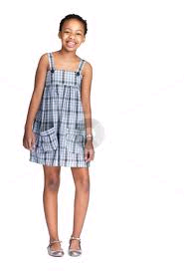Ring the correct word for the picture.

girl door

**Activities**

* Reading
* Spelling
* Ringing

**Period 3**

shot poem

(money, money, money)

Period 4

Content: Letter names

i j k I

write correctly.

/ = ___ = ___ / = ____ k = ____

j

Activities:

* Reciting
* Reading
* Writing

**Period 5**

Content: Preposition and colours

near black



Where is the …………..?

The ……… is …………… the ………

**Week 6**

**Period**

**Content: Letter names**

m n o p

__ __ __ __

Period 2: Colour (brown, orange)_

What is the colour of the soil?

Period 3 vocabulary

Key roof man pen

Read and draw:

pen ______ Key _____

roof ______ man _____

**Activities**

* Reading
* Drawing
* spelling
* sorting

**Period 4**

Situational game

Asking for permission

**Period 5**

Ringing the letters

 m 4 p

n o

Activities:

* Sorting
* Ringing
* reading
* writing

Week 7

Period 1 – letter names

read and write

q r s t

Period 2 shot poem

Period 3 Sentence construction

Simple sentences

Content

Read and draw.

It is a bed _______

It is a cup ________

It is a door ________

It is a tree ________

Period 4 Tongue twister

Period 5 Letter names

Content

Ring the correct letter.

s 2

2

t

t

t

Activities

* Reciting letters
* Reading
* Ringing
* Sorting

Week 8

Letter names

u v w x

_ _ _ _

**Period 2**

Situational game

Content: Requesting

May I have a …………… please!

**Period 3**

Content: Read and draw

* It is a mat _____
* It is a bag ______
* It is a leaf ______
* It is a kite ______

Period 4: Reciting colours: purple, pink

**Period 5Letter names**

u v w x y z

Content: Fill in the missing letters

a _ c __

a b _ d _

a _ _ d e _ _

Activities

* Reciting a – z
* Reading letters
* Writing
* Sorting